ETSI GR NFV-IFA 024 V4.4.2 (2023-03)
Network Functions Virtualisation (NFV) Release 4;
Information Modeling;
Report on External Touchpoints related
to NFV Information Model

Disclaimer: This DRAFT is a working document of ETSI. It is provided for information only and is still under development within ETSI. DRAFTS may be updated, deleted, replaced, or obsoleted by other documents at any time.
ETSI or its Members accept no liability for any current or further use/implementation of the present DRAFT.
Do not use as reference material.
Do not cite this document other than as "work in progress".
- ETSI NFV public DRAFTS are available in: http://docbox.etsi.org/ISG/NFV/Open/Drafts/
- Report FEEDBACK via the NFV issue tracker: http://nfvwiki.etsi.org/index.php?title=NFV_Issue_Tracker
- Approved and PUBLISHED deliverables shall be obtained via the ETSI Standards search page at: http://www.etsi.org/standards-search

Disclaimer
The present document has been produced and approved by the Network
Functions Virtualisation (NFV) ETSI Industry Specification Group (ISG)
and represents the views of those members who participated in this ISG.
It does not necessarily represent the views of the entire ETSI membership.
Group Report

Reference
RGR/NFV-IFA024ed451
Keywords
information model, NFV, UML

ETSI
650 Route des Lucioles
F-06921 Sophia Antipolis Cedex - FRANCE

Tel.: +33 4 92 94 42 00 Fax: +33 4 93 65 47 16

Siret N° 348 623 562 00017 - APE 7112B
Association à but non lucratif enregistrée à la
Sous-Préfecture de Grasse (06) N° w061004871

Important notice
The present document can be downloaded from:
http://www.etsi.org/standards-search
The present document may be made available in electronic versions and/or in print. The content of any electronic and/or print versions of the present document shall not be modified without the prior written authorization of ETSI. In case of any existing or perceived difference in contents between such versions and/or in print, the prevailing version of an ETSI deliverable is the one made publicly available in PDF format at www.etsi.org/deliver.
Users of the present document should be aware that the document may be subject to revision or change of status. Information on the current status of this and other ETSI documents is available at https://portal.etsi.org/TB/ETSIDeliverableStatus.aspx
If you find errors in the present document, please send your comment to one of the following services:
https://portal.etsi.org/People/CommiteeSupportStaff.aspx
If you find a security vulnerability in the present document, please report it through our
Coordinated Vulnerability Disclosure Program:
https://www.etsi.org/standards/coordinated-vulnerability-disclosure
Notice of disclaimer & limitation of liability
The information provided in the present deliverable is directed solely to professionals who have the appropriate degree of experience to understand and interpret its content in accordance with generally accepted engineering or
other professional standard and applicable regulations.
No recommendation as to products and services or vendors is made or should be implied.
No representation or warranty is made that this deliverable is technically accurate or sufficient or conforms to any law and/or governmental rule and/or regulation and further, no representation or warranty is made of merchantability or fitness for any particular purpose or against infringement of intellectual property rights.
In no event shall ETSI be held liable for loss of profits or any other incidental or consequential damages.

Any software contained in this deliverable is provided "AS IS" with no warranties, express or implied, including but not limited to, the warranties of merchantability, fitness for a particular purpose and non-infringement of intellectual property rights and ETSI shall not be held liable in any event for any damages whatsoever (including, without limitation, damages for loss of profits, business interruption, loss of information, or any other pecuniary loss) arising out of or related to the use of or inability to use the software.
Copyright Notification
No part may be reproduced or utilized in any form or by any means, electronic or mechanical, including photocopying and microfilm except as authorized by written permission of ETSI.
The content of the PDF version shall not be modified without the written authorization of ETSI.
The copyright and the foregoing restriction extend to reproduction in all media.

© ETSI 2022.
All rights reserved.

Contents
Intellectual Property Rights 4
Foreword 4
Modal verbs terminology 4
1 Scope 5
2 References 5
2.1 Normative references 5
2.2 Informative references 5
3 Definition of terms, symbols and abbreviations 6
3.1 Terms 6
3.2 Symbols 6
3.3 Abbreviations 6
4 Overview 6
4.1 Introduction 6
4.2 Relation to other ETSI NFV ISG Specifications 6
5 Touchpoints with external models 7
5.1 Touchpoints with ONF™ Core Model 7
5.2 Touchpoints with TM Forum model 8
5.2.1 Touchpoints with TM Forum Service Model 8
5.2.2 Touchpoints with TM Forum Resource Model 9
5.3 Touchpoints with 3GPP Models 10
5.3.1 Touchpoints with 3GPP Generic Network Resource Model 10
5.3.2 Touchpoints with 3GPP Network Slicing Model 10
5.4 Touchpoints with ETSI ISG ZSM 11
Annex A: Change history 13
History 14

Intellectual Property Rights
Essential patents
IPRs essential or potentially essential to normative deliverables may have been declared to ETSI. The declarations pertaining to these essential IPRs, if any, are publicly available for ETSI members and non-members, and can be found in ETSI SR 000 314: "Intellectual Property Rights (IPRs); Essential, or potentially Essential, IPRs notified to ETSI in respect of ETSI standards", which is available from the ETSI Secretariat. Latest updates are available on the ETSI Web server (https://ipr.etsi.org/).
Pursuant to the ETSI Directives including the ETSI IPR Policy, no investigation regarding the essentiality of IPRs, including IPR searches, has been carried out by ETSI. No guarantee can be given as to the existence of other IPRs not referenced in ETSI SR 000 314 (or the updates on the ETSI Web server) which are, or may be, or may become, essential to the present document.
Trademarks
The present document may include trademarks and/or tradenames which are asserted and/or registered by their owners. ETSI claims no ownership of these except for any which are indicated as being the property of ETSI, and conveys no right to use or reproduce any trademark and/or tradename. Mention of those trademarks in the present document does not constitute an endorsement by ETSI of products, services or organizations associated with those trademarks.
DECT™, PLUGTESTS™, UMTS™ and the ETSI logo are trademarks of ETSI registered for the benefit of its Members. 3GPP™ and LTE™ are trademarks of ETSI registered for the benefit of its Members and of the 3GPP Organizational Partners. oneM2M™ logo is a trademark of ETSI registered for the benefit of its Members and of the oneM2M Partners. GSM® and the GSM logo are trademarks registered and owned by the GSM Association.

Foreword
This Group Report (GR) has been produced by ETSI Industry Specification Group (ISG) Network Functions Virtualisation (NFV).

Modal verbs terminology
In the present document "should", "should not", "may", "need not", "will", "will not", "can" and "cannot" are to be interpreted as described in clause 3.2 of the ETSI Drafting Rules (Verbal forms for the expression of provisions).
"must" and "must not" are NOT allowed in ETSI deliverables except when used in direct citation.

1 Scope
The present document is an informative report defining the touchpoints/relations between the NFV Information Model ETSI GR NFV-IFA 015 [i.1] and information models from other organizations.

2 References

2.1 Normative references
Normative references are not applicable in the present document.

2.2 Informative references
References are either specific (identified by date of publication and/or edition number or version number) or non-specific. For specific references, only the cited version applies. For non-specific references, the latest version of the referenced document (including any amendments) applies.
NOTE: While any hyperlinks included in this clause were valid at the time of publication, ETSI cannot guarantee their long term validity.
The following referenced documents are not necessary for the application of the present document but they assist the user with regard to a particular subject area.
[i.1] ETSI GR NFV-IFA 015: "Network Functions Virtualisation (NFV) Release 3; Management and Orchestration; Report on NFV Information Model".
[i.2] Void.
[i.3] TM Forum GB922 R15.5.1: "TM Forum Information Framework".
[i.4] ONF™ TR-512: "Core Information Model (CoreModel) version 1.1", November 2015.
NOTE: Available at https://www.opennetworking.org/software-defined-standards/models-apis/.
[i.5] ETSI TS 128 622: "Universal Mobile Telecommunications System (UMTS); LTE; 5G; Telecommunication management; Generic Network Resource Model (NRM) Integration Reference Point (IRP); Information Service (IS) (3GPP TS 28.622)".
[i.6] ETSI GR NFV 003: "Network Functions Virtualisation (NFV); Terminology for Main Concepts in NFV".
[i.7] ETSI TS 128 541: "5G; Management and orchestration; 5G Network Resource Model (NRM); Stage 2 and stage 3 (3GPP TS 28.541)".
[i.8] ETSI GS ZSM 002: "Zero-touch network and Service Management (ZSM); Reference Architecture".
[i.9] ETSI GS ZSM 008: "Zero-touch Network and Service Management (ZSM); Cross-domain E2E Service Lifecycle Management".

3 Definition of terms, symbols and abbreviations

3.1 Terms
For the purposes of the present document, the terms given in ETSI GR NFV 003 [i.6] apply.

3.2 Symbols
Void.

3.3 Abbreviations
For the purposes of the present document, the abbreviations given in ETSI GR NFV 003 [i.6] and the following apply:
E2E End-to-End
MD Management Domain
ZSM Zero-touch network and Service Management

4 Overview

4.1 Introduction
The NFV Information Model, defined by ETSI GR NFV-IFA 015 [i.1], is focused on the management of the virtualisation aspects. Other models exist defined by other organizations and to provide an end-to-end model view, it is useful to be able to federate the NFV Information Model with other external models.
The approach used is to define interaction points between the NFV Information Model and some models from other organizations, allowing all organizations to extend their model based on the interaction points as they see needed.
The NFV Touchpoint Model, provided in annex A, only describes the touchpoints between various models.
The classes involved from each external model are defined in separate Papyrus models.
Both those external Papyrus models as well as the NFV Information Model are loaded as read-only in the NFV Touchpoint Model to create the needed relations between the models. This allows the NFV Information Model to remain independent of any external model.

4.2 Relation to other ETSI NFV ISG Specifications
The present document is referencing information from the following ISG NFV Group Specification:
- Network Function Virtualisation (NFV); Management and Orchestration; Report on NFV Information Model ETSI GR NFV-IFA 015 [i.1].

5 Touchpoints with external models

5.1 Touchpoints with ONF™ Core Model
For the current release of the NFV Information Model, the external Network Resource model is provided by the ONF™ Core Model [i.4].
The needed classes from the ONF™ Core Model are defined in the External Network Resource Model and are outside of ETSI NFV scope.
Figure 5.1-1 shows the touchpoints between the NFV Information Model and the External Network Resource Model at Virtualised Resource level.
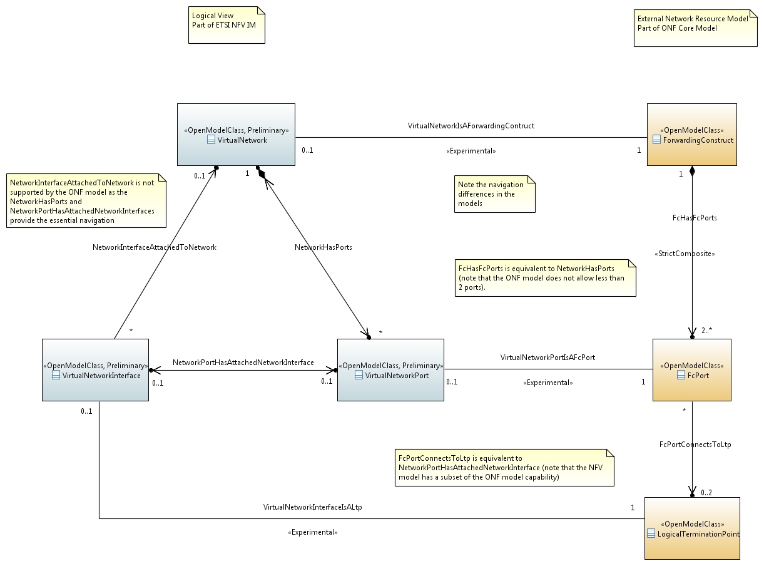
Figure 5.1-1: Touchpoints between NFV Information Model and
ONF™ Core Model at Virtualised Resource level
Figure 5.1-2 shows the touchpoints between the NFV Information Model and the External Network Resource Model at Virtual Link level.
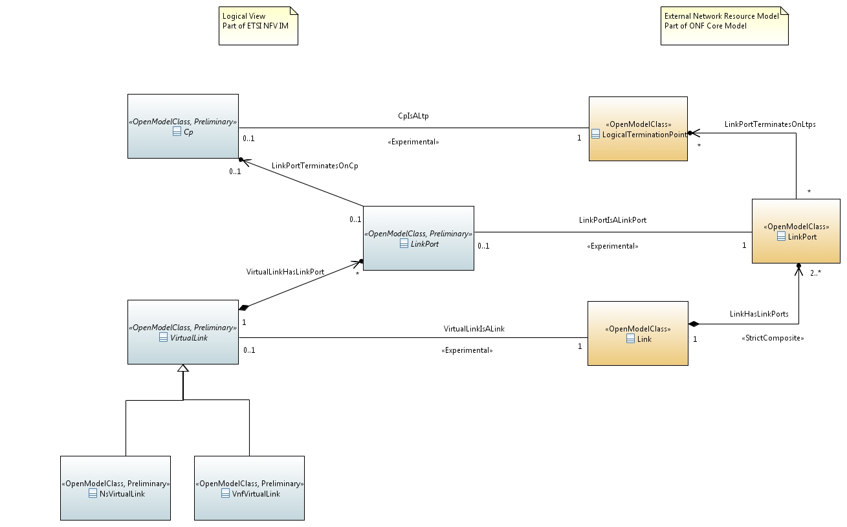
Figure 5.1-2: Touchpoints between NFV Information Model and
ONF™ Core Model at Virtual Link level

5.2 Touchpoints with TM Forum model

5.2.1 Touchpoints with TM Forum Service Model
For the current release of the NFV Information Model, the external Service Model is provided as a subset of the TM Forum Informational Framework [i.3] Service Model.
The needed classes are defined in the External Service Model and are outside of ETSI NFV scope.
Figure 5.2.1-1 shows the touchpoints between the NFV Information Model and the External Service Model.
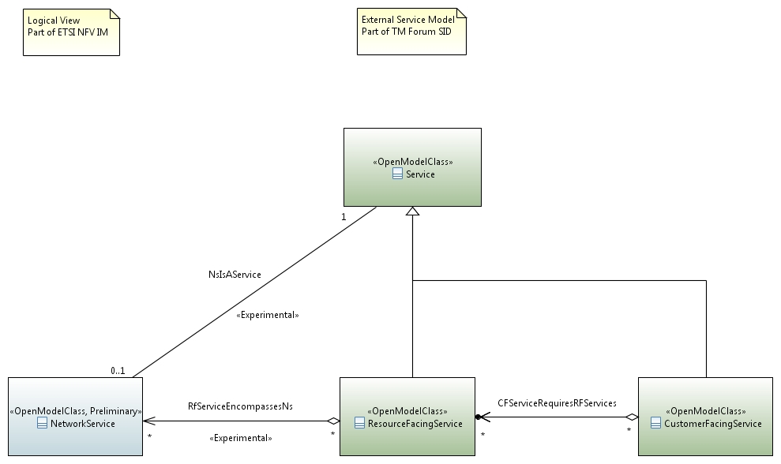
Figure 5.2.1-1: Touchpoints between NFV Information Model and External Service Model

5.2.2 Touchpoints with TM Forum Resource Model
For the current release of the NFV Information Model, the external Resource Model is provided as a subset of the TM Forum Informational Framework [i.3] Resource Model.
The needed classes are defined in the External Resource Model and are outside of ETSI NFV scope.
Figure 5.2.2-1 shows the touchpoints between the NFV Information Model and the External Resource Model.
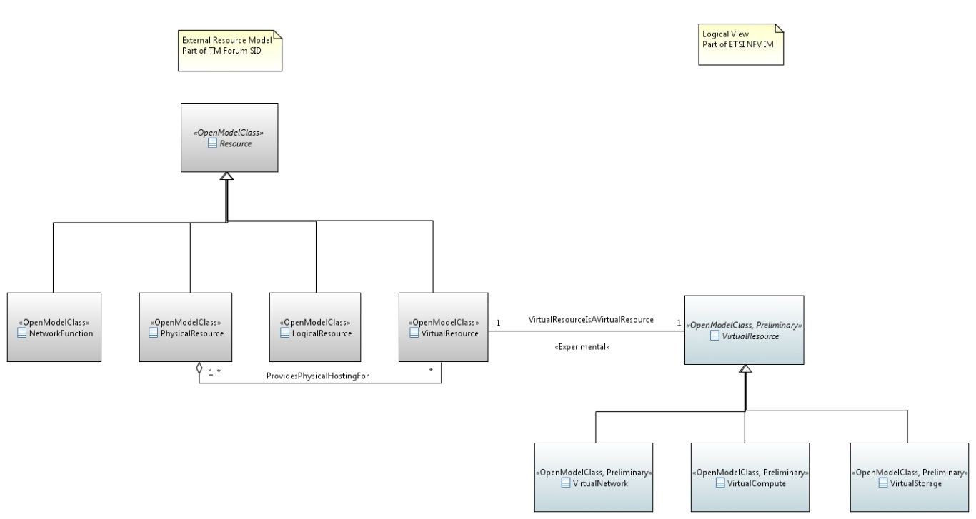
Figure 5.2.2-1: Touchpoints between NFV Information Model and External Resource Model

5.3 Touchpoints with 3GPP Models

5.3.1 Touchpoints with 3GPP Generic Network Resource Model
For the current release of the NFV Information Model, the external Application Model is provided as a subset of the 3GPP Generic Network Resource Model [i.5].
The needed classes are defined in the External Application Model and are outside of ETSI NFV scope.
Figure 5.3.1-1 shows the touchpoints between the NFV Information Model and the External Application Model.
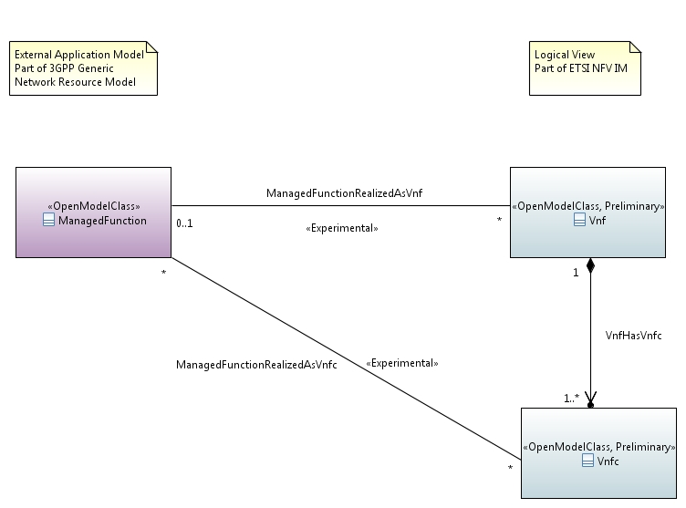
Figure 5.3.1-1: Touchpoints between NFV Information Model and External Application Model

5.3.2 Touchpoints with 3GPP Network Slicing Model
For the current release of the NFV Information Model, the touchpoint to network slicing is defined according to ETSI TS 128 541 [i.7], in clause 6.2.1.
The needed classes describing the network slices and subnets as well as the managed functions used for the slices are defined in 3GPP and thus outside of ETSI NFV scope.
Figure 5.3.2-1 shows the touchpoints between the NFV Information Model and the Network Slicing Model.
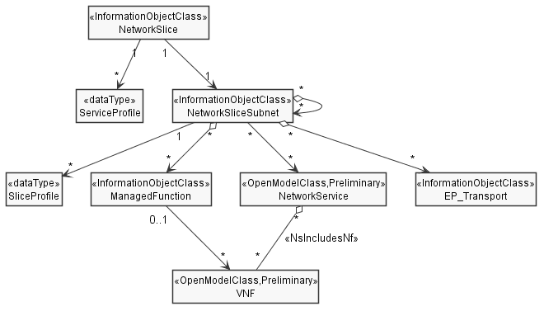
: Part of ETSI NFV IM

Figure 5.3.2-1: Touchpoints between NFV Information Model and Network Slicing Model

5.4 Touchpoints with ETSI ISG ZSM
ETSI ISG ZSM provides an architecture for zero-touch automation of network and service management. In this architecture, ETSI NFV MANO can act as a Management Domain (MD). The concept of management domains is defined in ETSI GS ZSM 002 [i.8]. Figure 5.4-1 shows this relation in a simplified way, as defined in ETSI GS ZSM 008 [i.9], clause 4.
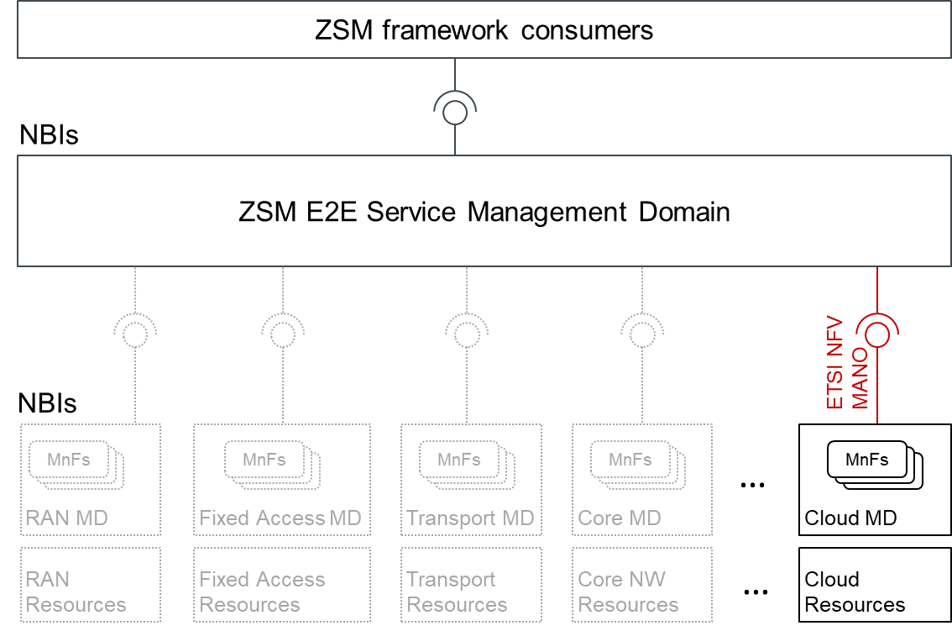
Figure 5.4-1: NFV MANO in the ETSI ZSM framework reference architecture
The NFV management domain here integrates to the E2E Service Management Domain or to an intermediate level management domain, which consumes parts of the NFV model exposed over the Os-Ma-nfvo reference point.
A detailed mapping can be found in clause 6.6 of ETSI GS ZSM 008 [i.9].

Annex A:
Change history
Date | Version | Information about changes
13 December 2018 | V3.0.0 | Base version for release 3
18 January 2019 | V3.0.1 | NFVIFA(18)0001091 FEAT05 IFA024 Add Slicing Touchpoint
19 June 2020 | V4.0.1 | Base version for release 4
29 June 2021 | V4.2.2 | Initial version for Release 4 drop 3
21 October 2021 | V4.2.3 | NFVIFA(21)000868r2 - IFA024 update touchpoint for network slicing  NFVIFA(21)000869r3 - IFA024 Touchpoint with ZSM
23 March 2023 | V4.4.2 | Initial version for Release 4 drop 5

History
Document history
V4.2.1 | May 2021 | Publication
V4.3.1 | June 2022 | Publication

