A role for ETSI in the area of Digital Media Content Delivery?

Background
Today, digital media content delivery is exploding on a number of fronts. In addition of the move from analogue to digital television services, consumers are able to receive content delivered via the Internet, via IPTV, and via mobile. Delivery formats include standard broadcast, unicast (e.g. 3G streaming services), and technologies such as peer-to-peer. Content delivery by its very nature also includes a number of restrictions and rules regarding rights; as a result content protection schemes such as conditional access and digital rights management must be accounted for.
At an even deeper level, the delivery of content in a digital format lends itself well to incorporating tags and metadata which users can search on to find archived content.
Consider the environment however in which this is occurring within Europe, and indeed other parts of the world. Standards vary from market to market when it comes to mobile television. There are at least four viable platforms in the European market today: DVB-H, the incumbent and long-expected “winner” for mobile television; DVB-T, the terrestrial broadcast standard delivering mobile television content in Germany and Austria; DMB, the standard with both a terrestrial and satellite component in Korea, soon to be used in Norway by NRK; and MediaFLO, the standard promoted by Qualcomm, deployed in the USA with AT&T and Verizon, and in ownership of 70 MHz of L-band spectrum in the United Kingdom.
Consider also the environment which the consumer faces. In the case of mobile television (whether broadcast or unicast via 3G), the consumer is generally forced into paying a monthly tariff for programming. The quantity of channels available is limited (given the limited spectrum currently available in most markets for mobile TV) and a general “buy before you try” mentality has stunted growth. This has long been the pattern until recently when free-to-air services became available through the provision of devices in Germany and Austria during Euro2008 with built-in DVB-T receivers. Operators in Italy and Holland are now working to try and create a consumer behavior and desire for mobile television by offering channels included in the mobile subscription over their DVB-H mobile broadcast networks. The point of this is that the market has demonstrated confusion in terms of how it wants to interact with its end consumer.
In this mixed up world of distribution and business models, it is generally only the content provider who has it “easy” since it is no real challenge to provide content to the various distribution pipes. However, content providers will fail to make money in this scenario given that the entire ecosystem is broken and confusing to the end consumer. Operators are torn in terms of standards to back and must somehow justify the cost to build out new infrastructure for digital services (e.g. IPTV, mobile television) when the business model doesn’t show decent returns on investment. Much of this is fallout which remains from the 3G spectrum auctions where operators clearly spent a massive amount of money on both licenses and on new infrastructure. Device manufacturers are left to try and guess which standard(s) are likely to be required in their terminals, and today, will necessarily be stuck with that core design question: do I design for a minimum number of device types, piling in extra cost to serve multiple standards or do I try and drive for a lower cost by “guessing” which standards will win and only building those into my terminal.

Specific changes in dynamics and business roles in DMCD. (change title)
Traditionally the two worlds of specification, Broadcast and telecoms are separated, until now this had no real impact on business. Times are changing and the technology challenge is the merger of on demand, interactive media consumption and programmed broadcasted media consumption. In a sense a merger that already happened in printed and online media.
Etis is host to both telco related standardization as broadcast related standardization, The DMCD would be a opportunity to get insight in the standards field on both sides and assess where they merge. This is specifically the case with some digital broadcast systems that have a service separation on IP level.
In general the rules of economics are that content and business models around them only sell based on a considerable reach. And that technology innovation that drive integration of multiple technology standards into one device only happen if there is a big perceived market.

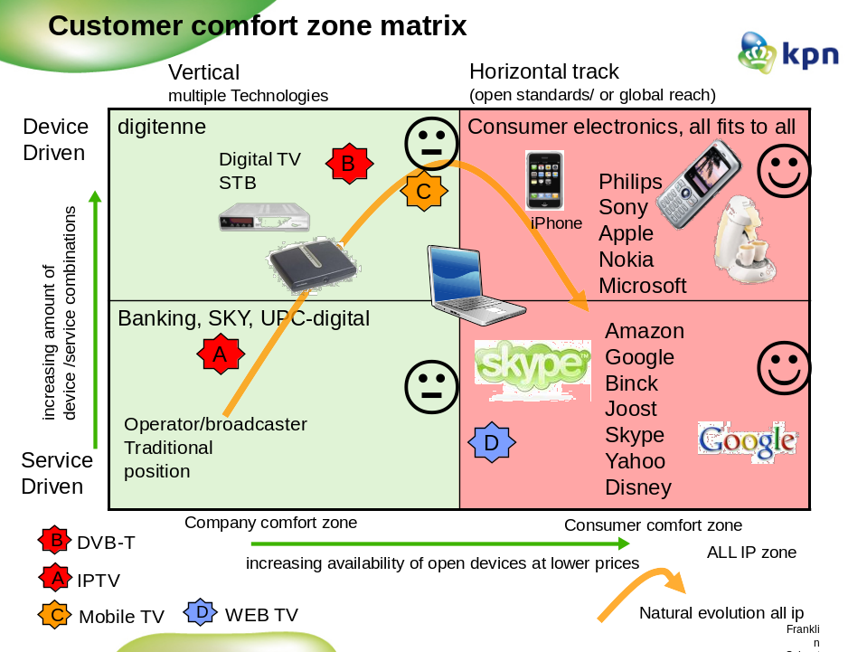

Framework considerations for DMCD
Given this backdrop, there is a clear role that ETSI can play to help straighten things out. The framework needs to assess the process of content creation through to content delivery and include all of the players which will be a part of the ecosystem. That means it must take into account the needs and expectations of: content providers, broadcast operators, network operators, advertisers, analytics, regulators, device manufacturers, and end consumers. A framework must take into considerations that technology is to allow the creativity to design multiple business models without pinning the business models down in the framework itself.
Though harmonization might be a desirable outcome , one should not automatically make an assumption that this is essential for success , and of course if at all achievable in current situation. Why would this be? Consider how rapidly technology is evolving from a radio perspective. Numerous higher end phones (e.g. Nokia N series, Apple iPhone, HTC Windows Mobile devices) are all including both multiband UMTS transceivers along with 802.11 capability. A combined DVB-T/H receiver exists today, and adding additional mobile television receiver types is well within the bounds of possibility. The more economical essence behind harmonization is based on capacity. As an example in a broadcast mode it seems not economical to replicate spectrum to deliver similar content.
Looking at the environment for DMCD, the service level seems to be a key enabler from a customer perspective. This means special attention towards service level interoperability is necessary within DMCD. The typical discussed use cases in the group all targeted cross platform content delivery to one identified customer. This places the DMCD work on the difficult areas like content protection, user interface, meta tagging, presentation languages. This means that the work should address these issues but also leave room for creativity on .e.g. user interfaces.
Thus, ETSI could provide guidance in the following areas:
- Describing a DMCD framework in requirements sense, e.g. portability across different screens etc.
- Mapping of current standards, how does a standard plot in the framework and what is it’s relation to other standards.
- A gap analysis indicating the challenges in the end to end delivery of content including analysis of current and future business dynamics.
- Recommendations on implementations (combinations of standards) aimed at enabling a viable scenario’s and fulfill the basic requirements of a DMCD framework.
- Provide the basis for Inter standard profiling to realize this DMCD framework vision.
As a backdrop to this effort, several key factors need to be kept as guiding principles. First and foremost, a diversity of business models must be able to flourish. Having only one or two business models available is likely to clamp on innovation of solution delivery. Second, standards recommendations should support an open market approach. Third, achieving interoperability at the service level is highly recommended. This will drive scale on a global level and give consumers the trust they need to decide on a purchase.

Technical, business and market environment for DMCD
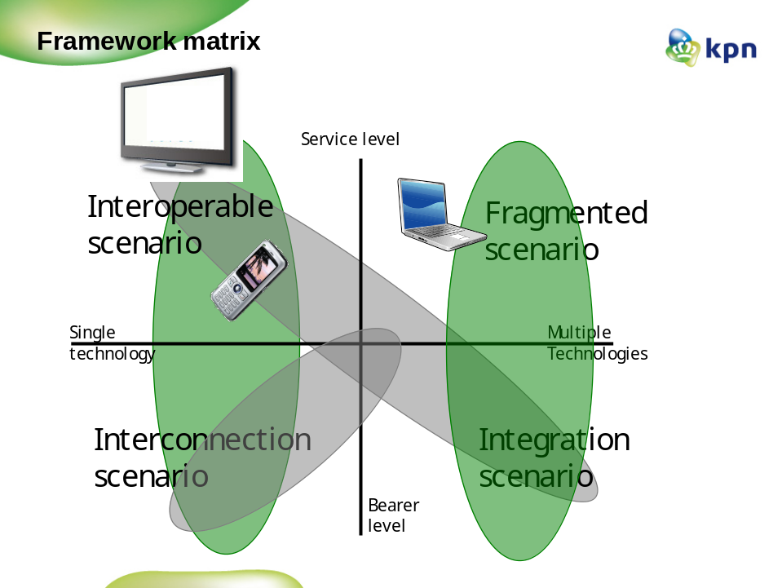

Assumptions
Interoperability at the service level is most important to reach mass market and customer acceptation.
Interoperabiliy meaning It should be possible to consume protected media on any device using standard solutions. Specific customer wish is that Media can be consumed across devices that are under control of a certain person.

Integration on bearer level meaning that several bearers can be integrated in once device without blocking media consumption for the end user.
Interconnection on bearer level meaning, bearers that serve different type of end user services can be interconnected to provide a combined service across the different used bearers. E.g. DVB-T with IP return, or DVB-H

Terms of Reference DMCD

DMCD work
Provide guidance in the following areas:
- Describing a DMCD framework in requirements sense, e.g. portability across different screens etc.
- Mapping of current standards, how a standard plot in the framework does and what is it’s relation to other standards.
- A gap analysis indicating the challenges in the end to end delivery of content including analysis of current and future business dynamics.
- Recommendations on implementations (combinations of standards) aimed at enabling a viable scenario’s and fulfill the basic requirements of a DMCD framework.
- Provide the basis for Inter standard profiling to realize this DMCD framework vision.
- Facilitate regulatory issues discussions with relevant bodies that are identified within the framework.
- Liaisons’ with other relevant standard bodies or organizations.
- Providing overall guidelines to other ETSI Technical Bodies to ensure a co-ordinated approach to the development of standards for digital media distribution across unicast, multicast and broadcast networks.

DMCD is the competence centre for:
- Convergence of broadcast, internet and telecommunications standards in relation to digital media distribution.
- Organizing or steering workgroups to make integration or interoperability possible between different “ETSI” standards used to for similar functionality.
- Arrange a platform where new business models and use cases can be discussed in the context of economics and global dynamics in order to assess viability of a given standard.
- Coordinate cross standard commercial requirements and use cases.
- Start standard work on areas where a significant Gap is recognized.
- Build liaisons with other working groups and SDO’s

DMCD is responsible for cross coordination of standards activities.
- The main objective of DMCD is to
  - Coordinate different “ETSI” initiatives that address basically the same functions in the DMCD domain.
  - Include in the coordination also external SDO work
  - make framework description of the DMCD landscape as a collection of standards and architectures that can fulfil the basic requirements of the DMCD group.

Collaboration with other bodies (both inside and outside ETSI)
In conjunction with the above Terms of References the following are noted:
• Providing overall guidelines to other ETSI Technical Bodies to ensure a co-ordinated approach to the development of standards for digital media distribution across unicast, multicast and broadcast networks.
• Liaising and collaborating with the European Union on regulation, EC Directives and other on issues in the DMCD area
• Co-ordinating ETSI positions in the DMCD area
• Cooperation and maintaining good relations with other appropriate bodies, taking into account the list of ETSI’s external relations agreements.

